SOPHOS XG FIREWALL: INTERFACE CONFIGURATION AND SECURITY POLICIES

- INTRODUCTION

This document shows the full process used to configure Sophos XG Firewall in a VMware virtual environment and implement three security policies for a virtual lab. The primary goal was to enforce granular security controls, including web filtering, application control, and firewall rules, for client virtual machines operating on a Host-Only network (vmnet1). The final document includes step-by-step configuration instructions, verification tests, and troubleshooting notes.

LAB NETWORK TOPOLOGY

Device | Interface | Network Type | Zone | IP Address | Notes
Sophos XG VM | NIC1(Port1) | Hostonly(vmnet1) | LAN | 192.168.56.72/24 | Internal Network Gateway
Sophos XG VM | NIC2(Port2) | Bridged | WAN | 192.168.88.31/24 | For internet access
Kali VM | NIC | Hostonly(vmnet1) |  | 192.168.56.30/24 | Client VM (Default Gateway: 192.168.56.72)
Host Machine | vmnet1 Adapter | Hostonly |  | 192.168.56.1/24 | Used for Sophos GUI access

Traffic Flow:

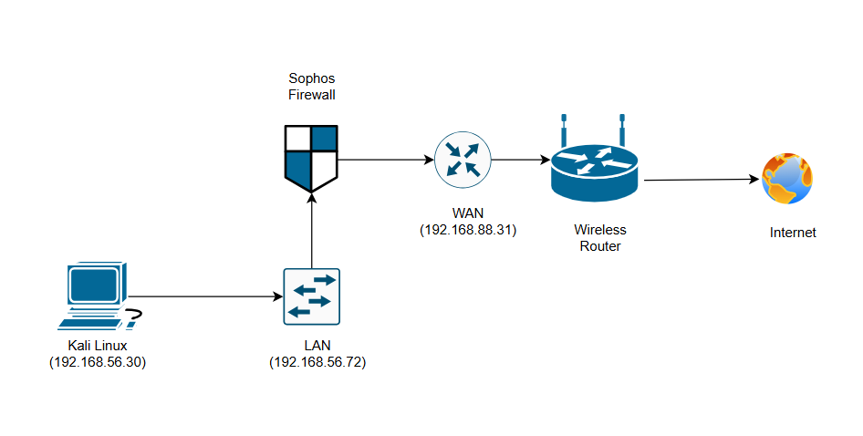Fig 1. Network topology
- Sophos XG Initial Network Interface Configuration:

Access the Sophos Admin Console from the Host Machine at https://192.168.56.72:4444

- Configure LAN Interface (Port1)
This sets the static IP for the internal network gateway.

- Navigate to Network ---> Interfaces.
- Click the hamburger icon next to the interface corresponding to NIC1 (Port1), then click on edit interface.
- Name: LAN
- Network Zone: Select LAN.
- Interface Type: Select Static.
- IPv4 / Netmask: Enter 192.168.56.72 and /24 (or 255.255.255.0).
- Click Save.
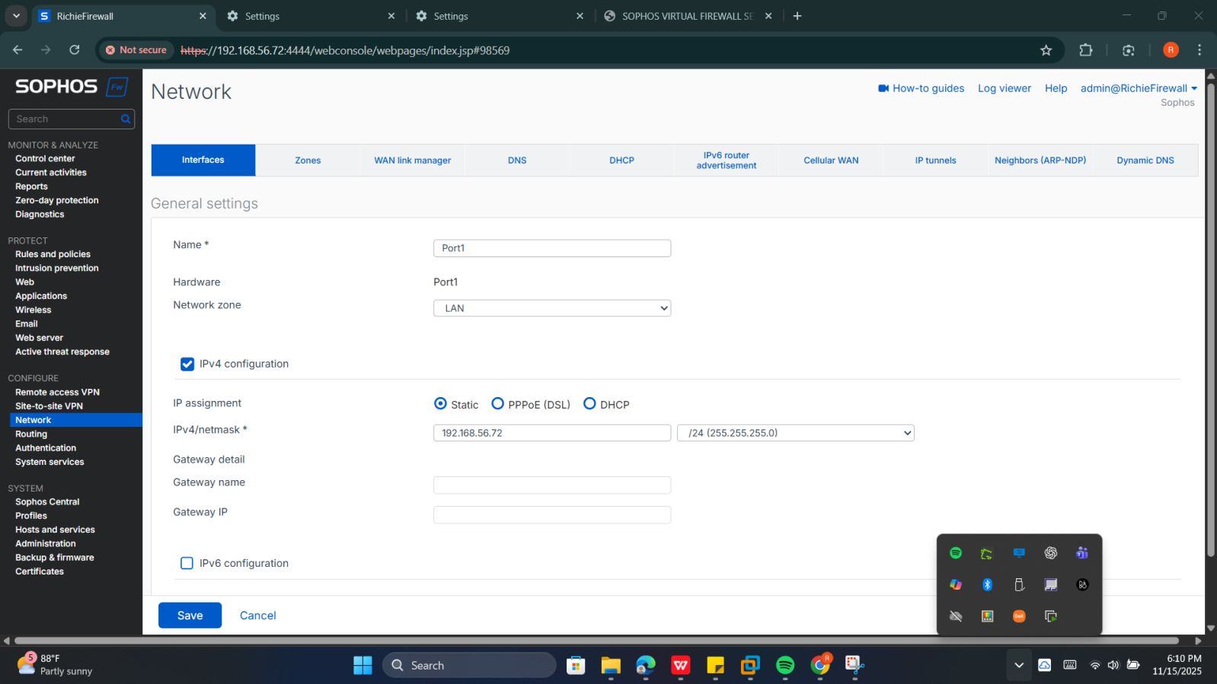
Fig.2 Port1 configuration

- Configure WAN Interface (Port2)
This connects the firewall to the external network.
- Click the Edit icon next to the interface corresponding to NIC2 (Port2).
- Name: WAN
- Network Zone: Select WAN.
- Interface Type: Select DHCP (Recommended for home labs to receive an IP like 192.168.88.31).
- Click Save.
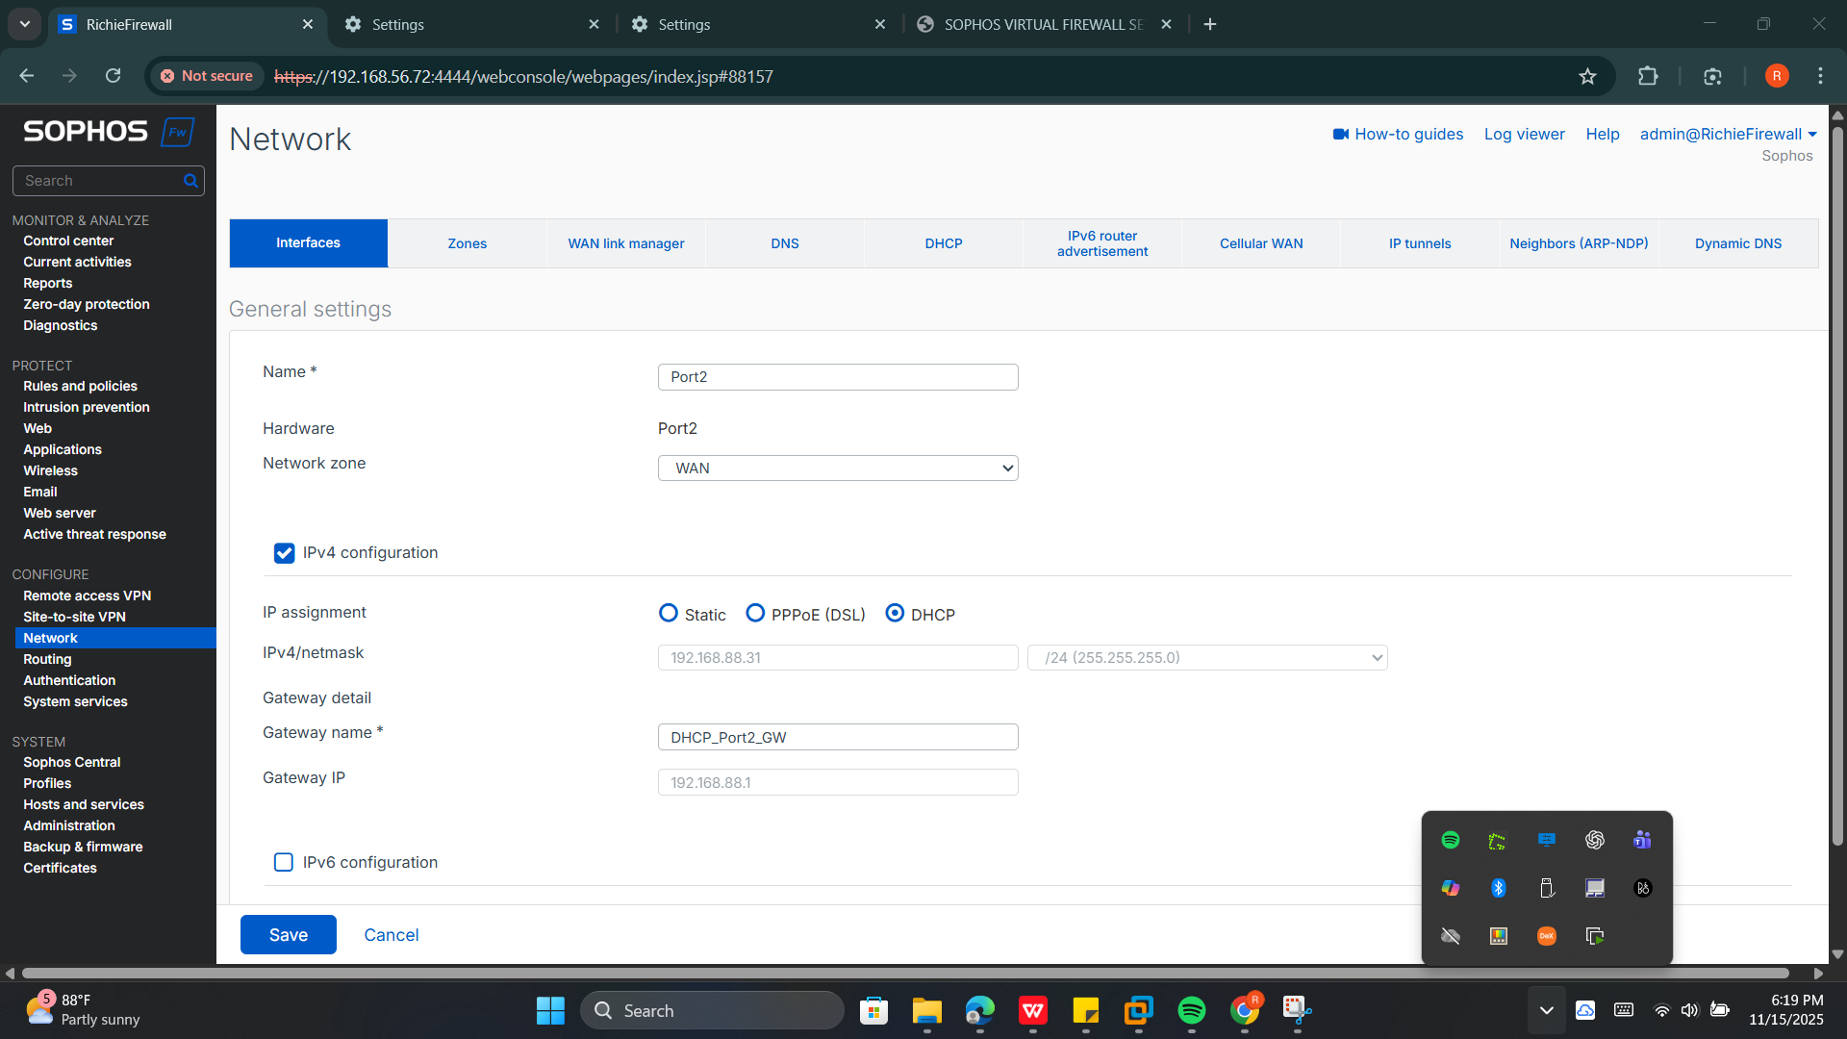
Fig. 3 Port2 configuration

- Security Policy Implementation

All policies are created under Rules & Policies ---> Firewall Rules. Rule order is critical, blocking rules must be placed above general allow rules.

Policy 1: Allow_LAN_to_Internet (General Fallback Rule)

- Click on Rules & Policies ---> Firewall Rules ---> Add Firewall Rule ---> New Firewall Rule
- Configure:
- Rule Name: Allow_LAN_to_Internet
- Source Zone: LAN
- Source Networks: LAN Network (or specify 192.168.56.0/24)
- Destination Zone: WAN
- Destination Networks: Any
- Services: Any
- Action: Allow
- Security Features: leave Web Filter and App Control blank here, to keep this as a general fallback rule.
- Save the rule and keep it as the fallback lower priority rule.

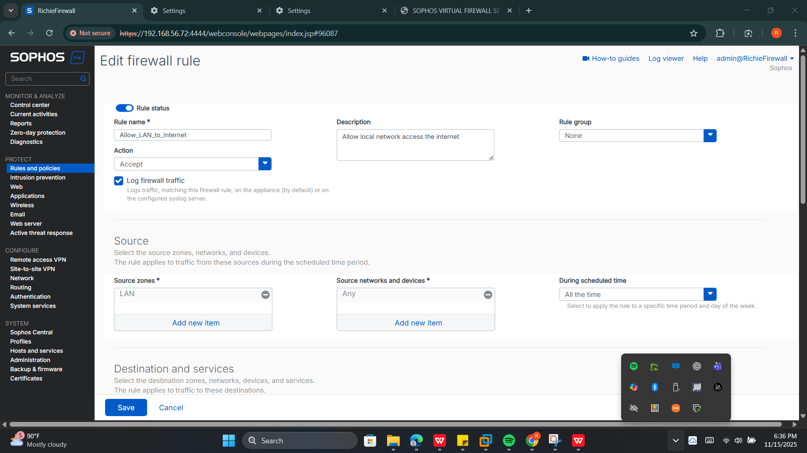
Fig. 4 Policy 1 implementation
Policy 2: Block Social media/Gambling/Adult content

Enforce content filtering to block specific categories of websites for all LAN users.
- Create Web Policy: Web ---> Policies ---> Add Policy.
- Name: Block_Social_Media/Gambling/Adult
- Set Action to Block for categories: Games and Gambling, Nudity and Adult content, and Social Networking.
- Then turn it on by toggling the button under status
- Then Save
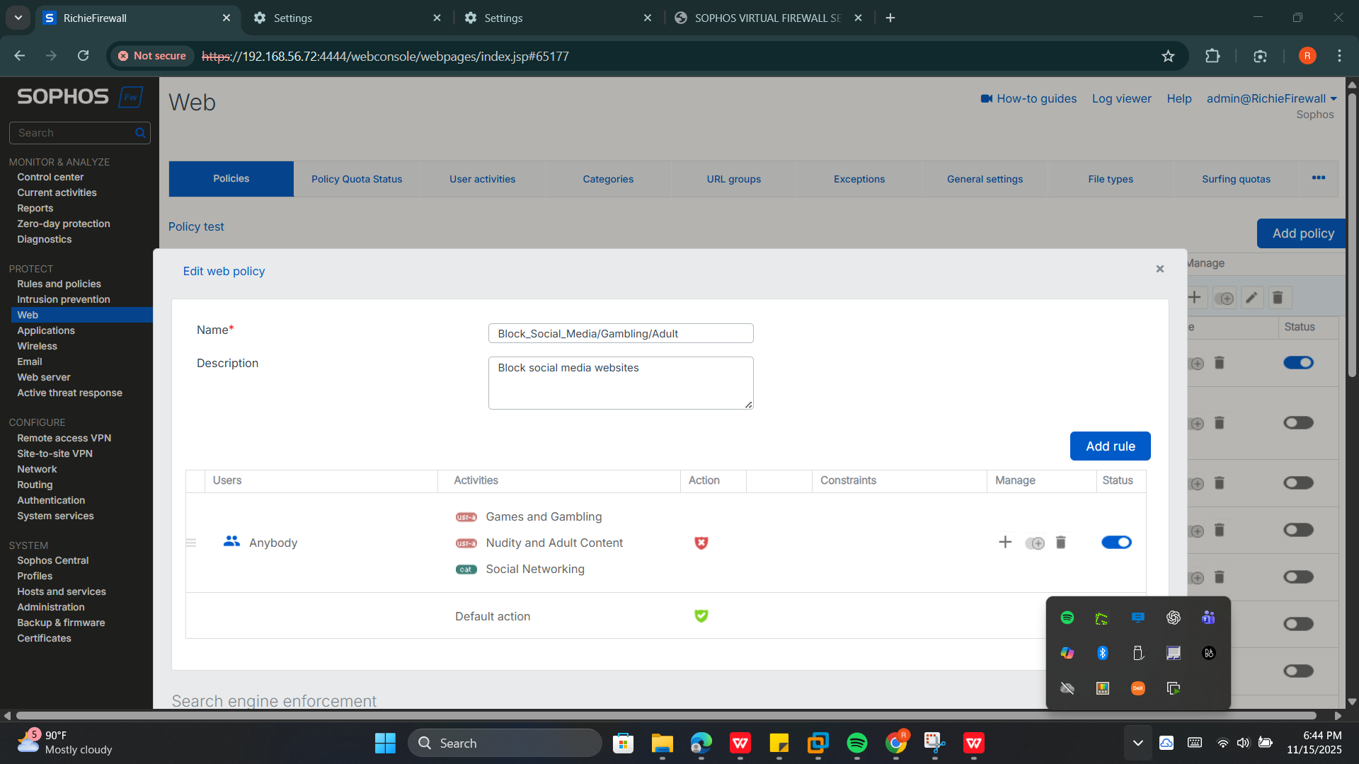
Fig. 5 web policy for Policy 2
- Create Firewall Rule:

- Rule Name: Block_Social_Gambling_Adult
- Source/Destination: LAN to WAN, LAN Network to Any.
- Services: HTTP, HTTPS (Restricts scope to web traffic).
- Action: Accept (This allows the firewall to intercept and show a block page).
- Security Features: Web Filter: Attach Block_Social_Media/Gambling/Adult.
- Placement: Above Allow_LAN_to_Internet
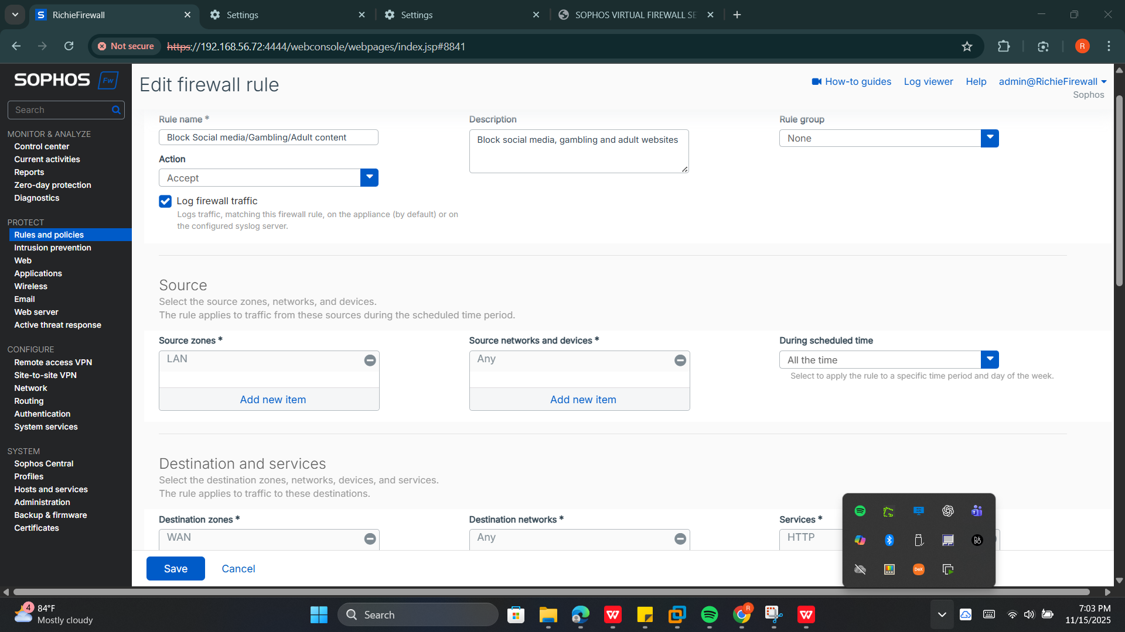
Fig. 6 Policy 2 implementation
Policy 3: Block P2P Apps (Application Control)

Objective: Use deep packet inspection to detect and block Peer-to-Peer (P2P) traffic.

- In Sophos XG, we can’t add a new application policy, so we will be using a predetermined policy which is Block peer to peer (P2P) networking apps

- Create Firewall Rule:
- Rule Name: Block P2P Apps
- Source/Destination: LAN to Any, LAN Network to Any.
- Services: Any (Allows App Control to inspect all ports).
- Security Features: Application Control: Attach Block peer to peer(P2P) networking apps policy.
- Placement: Placed second in the rule list, below Policy 2.

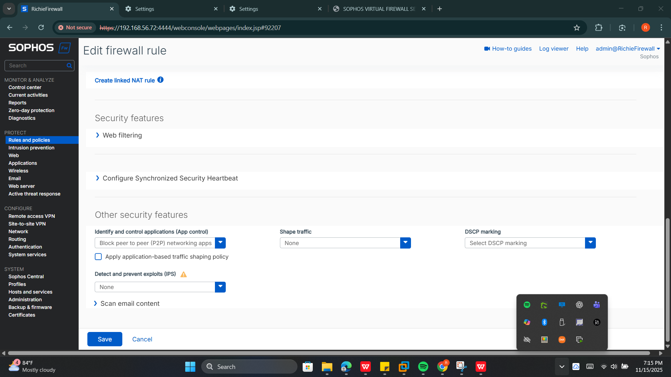
Fig. 7 Policy 3 implementation

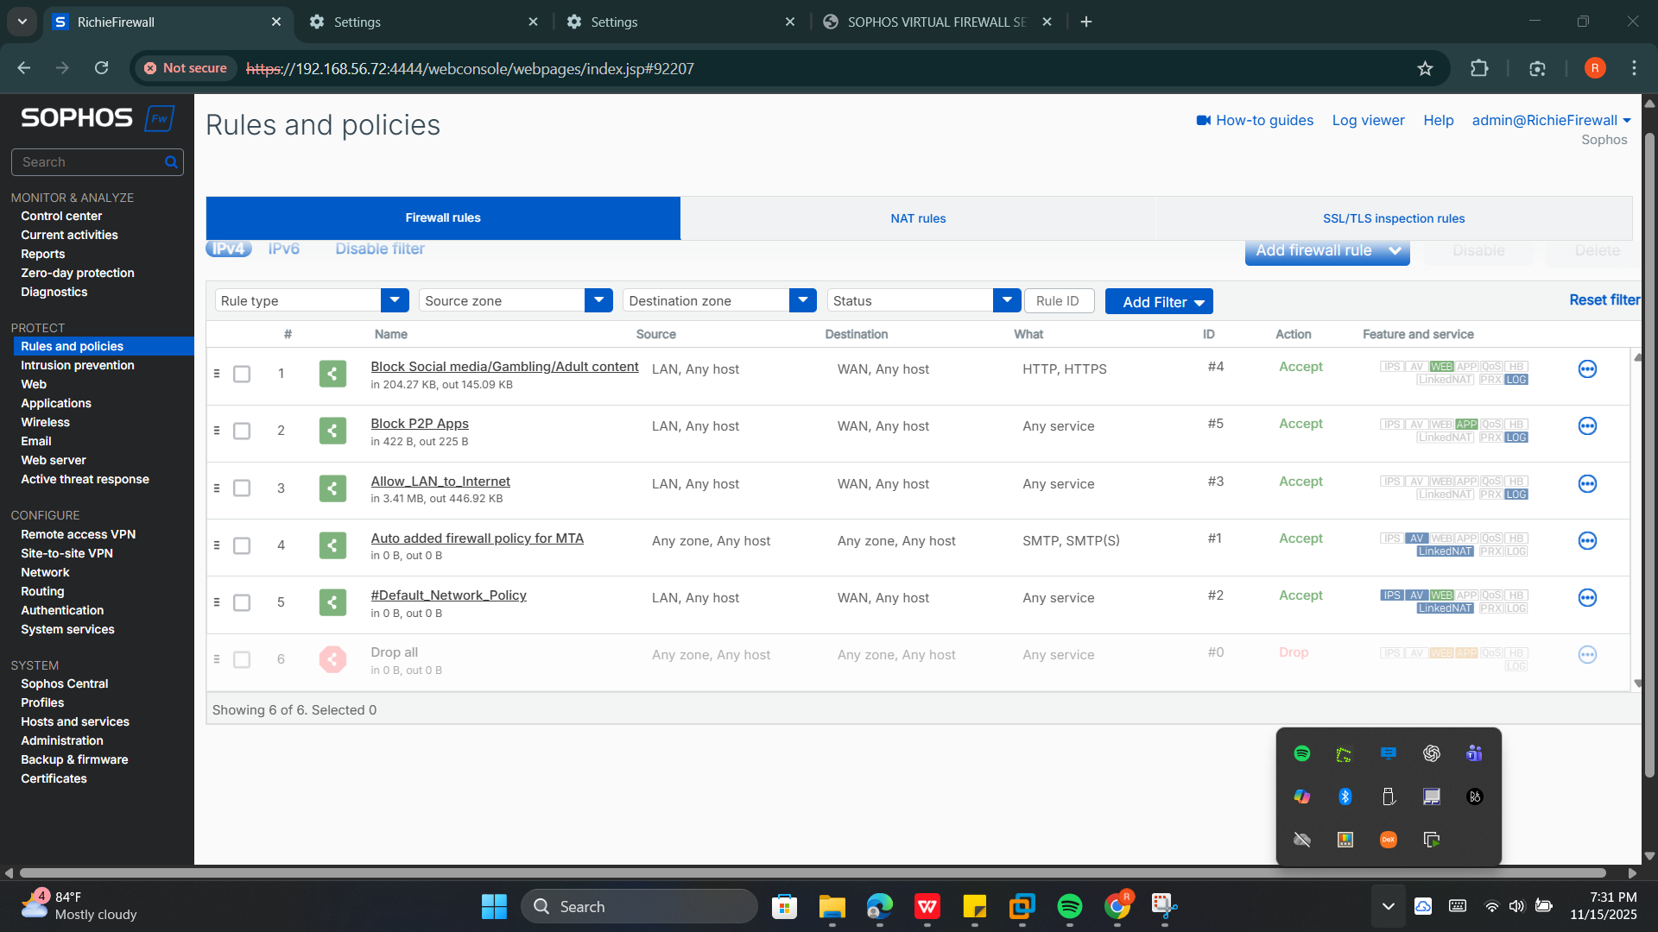
Fig. 8 All rules and policies

Testing & Verification Performed on Kali Linux
- Confirm default gateway and first hop:

ip route show default
traceroute -n 8.8.8.8 #first hop should be 192.168.56.72

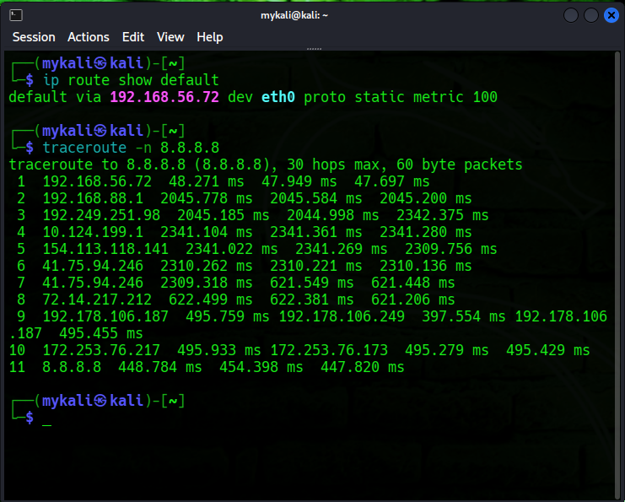
Fig 8. This confirms that traffic is being routed through sophos from kali

- Attempt to visit blocked sites (results observed)

- https://sportybet.ng (Gambling) --> blocked

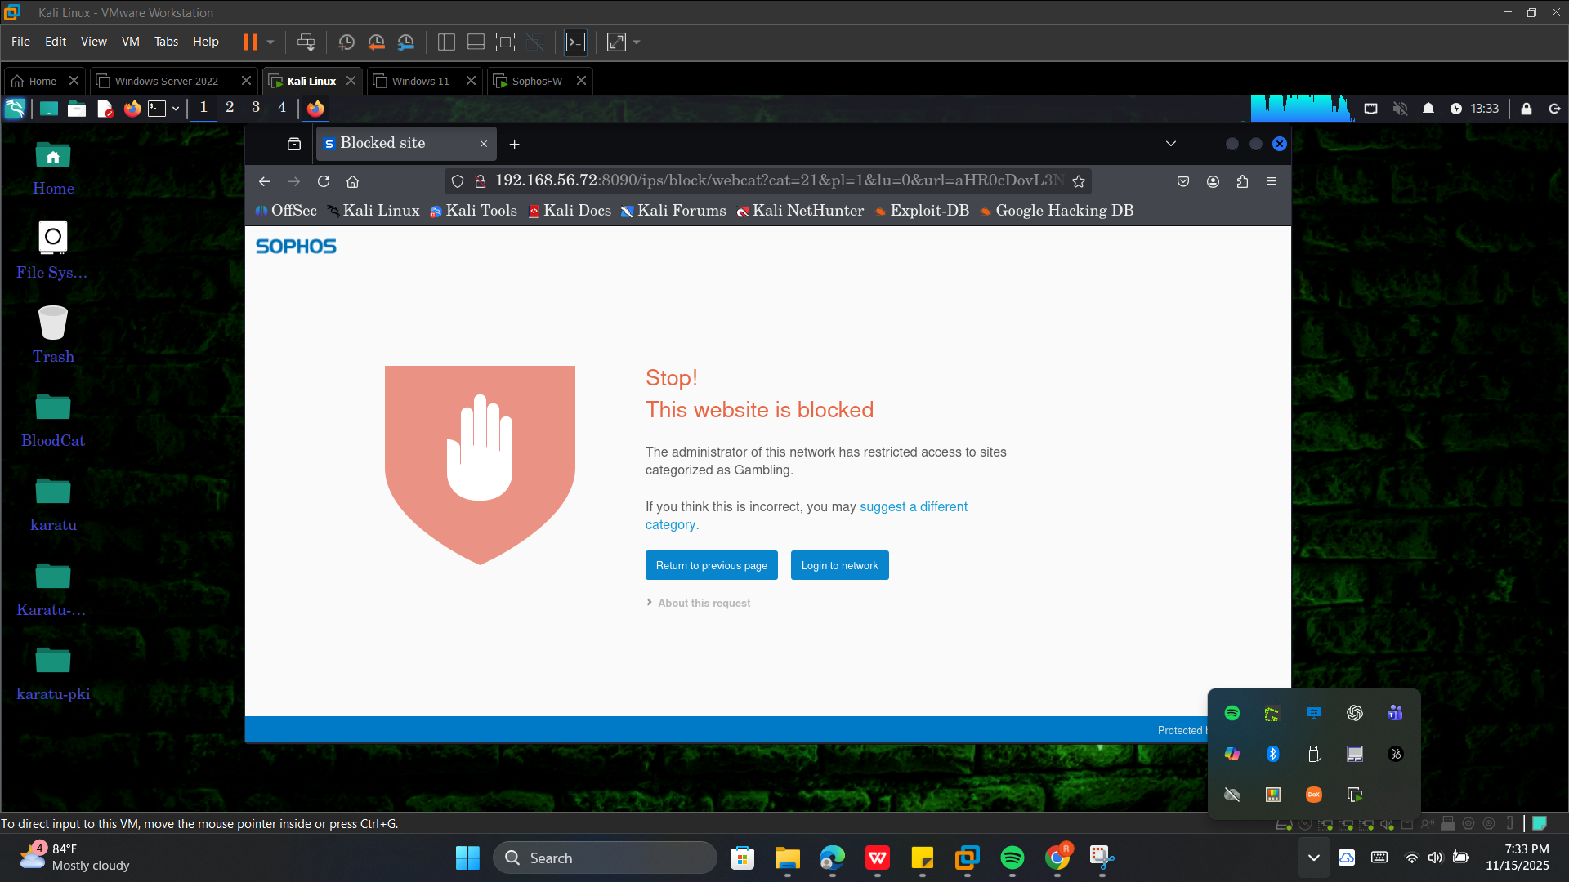

- https://facebook.com (social media) ---> blocked
